***“Errands with Heart”***

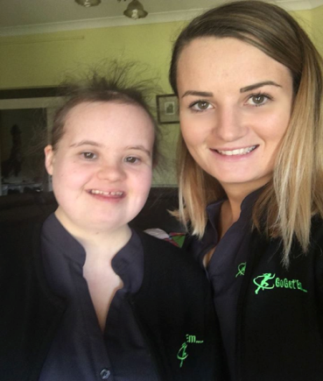

***Go Get ’Em: Errands with Heart.***

Go Get ‘Em is a registered business which runs Emily’s business and employs Kiera, Emily’s Business Assistant. Go Get ‘Em is a *microbusiness;* what this means is that it exists only to provide for Emily’s direct benefit. It is a vehicle for Emily’s growth, development and independence.

Emily is working for four businesses, around 10 hours per week. She does a range of jobs including: Watering plants, Shredding paper, Picking up and dropping off mail, Banking, Picking up/dropping off small parcels, Shopping for Office groceries (tea, coffee, milk, biscuits), and Office supplies (from Officeworks), Tidying cupboards and Personal assistant roles. There is probably room for one more customer. We have found local businesses have been both intrigued and very supportive of Emily’s business and we have not had an issue finding customers, in fact quite the opposite!

Go get ‘Em has been amazingly successful. Em is just so happy working in her business, and so proud of herself. It’s made a massive difference in her life so thanks to all at the Community Living Project, Micro Enterprise Project, particularly Jayne, for sharing your wisdom with us to get us started. Em likes the structure and routine that her business gives to her.

Emily is proud of her own logo which she designed, business cards, pens and work clothes. Recently we went out to a friend’s birthday. Em started handing out her cards, and telling people about her business. As a result we are fielding calls enquiring about engaging her. She is an exceptional marketer!  People just like the business idea, know it’s for Em and also see value in getting a hand… her work is useful and valued to them.

